# Chapter 1

# Introduction

A **screw thread**, often shortened to **thread**, is a [helical](https://en.wikipedia.org/wiki/Helix) structure used to convert between rotational and linear movement or force. A screw thread is a ridge wrapped around a [cylinder](https://en.wikipedia.org/wiki/Cylinder_(geometry)) or [cone](https://en.wikipedia.org/wiki/Cone_(geometry)) in the form of a helix, with the former being called a *straight* thread and the latter called a *tapered* thread. A screw thread is the essential feature of the [screw as a simple machine](https://en.wikipedia.org/wiki/Screw_(simple_machine)) and also as a [threaded fastener](https://en.wikipedia.org/wiki/Threaded_fastener)..

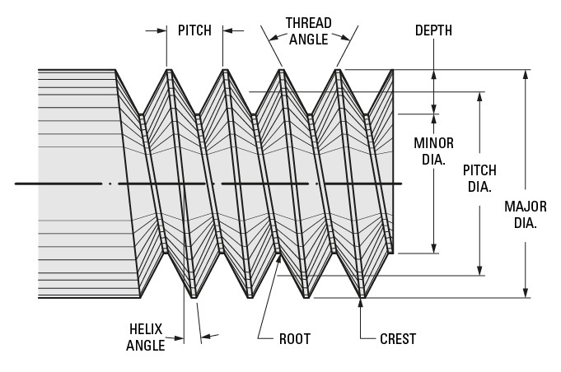

**Figure 1.1**

The [mechanical advantage](https://en.wikipedia.org/wiki/Mechanical_advantage) of a screw thread depends on its *lead*, which is the linear distance the screw travels in one revolution.[[1]](https://en.wikipedia.org/wiki/Screw_thread#cite_note-1) In most applications, the lead of a screw thread is chosen so that [friction](https://en.wikipedia.org/wiki/Friction) is sufficient to prevent linear motion being converted to rotary, that is so the screw does not slip even when linear force is applied, as long as no external rotational force is present.

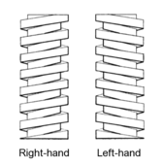

**Figure 1.2**

A screw thread, often shortened to thread, is a helical structure used to convert between rotational and linear movement or force. A screw thread is a ridge wrapped around a cylinder or cone in the form of a helix, with the former being called a straight thread and the latter called a tapered thread

# Chapter 2

# Literature Survey

A **screw thread** may be considered as an advanced form known as a helix. Or  A **screw thread is a ridge** wrapped around a cylinder or cone in the form of a helix, with the straight threads and later known as **tapered threads**.

The thread can be external, such as on a bolt or screw, or internal, such as inside a nut. A screw thread is the essential feature of the screw as a simple machine and also as a fastener.

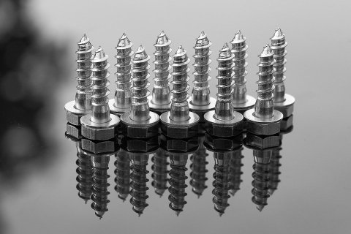

Screws Fasteners means, In all kinds of joining, the various parts are held together by devices known as fastening, and the elements by which the parts are so joined are called fasteners or fastening elements.

### ****Types of Fastening****

**There are two types of fastening used in engineering practice**:

1. Temporary fastening
2. Permanent fastening

Temporary fastenings are those in which repeated assembly or disassembly. It is possible without injury or damage to the fastener or to the part. In temporary fastenings, the parts are held together by fasteners such as screws, [bolts, nuts](https://www.theengineerspost.com/types-of-nuts-and-bolts/) keys, cotter, pins, etc.

**Threads are applied to many devices for various purposes some are as follows:**

1. To convey materials as in a gravity conveyor.
2. To transmit power,
3. It increases the efficiency of the applied effort as in an auto-jack.
4. To control movement as in a [micrometre](https://www.theengineerspost.com/types-of-micrometers-screw-gauge/).
5. To hold parts together as in the case of fastening.

# Chapter 3

# Types of Screw Thread

# The helix of a thread can twist in two possible directions, which is known as *handedness*. Most threads are oriented so that the threaded item, when seen from a point of view on the axis through the center of the helix, moves away from the viewer when it is turned in a [clockwise](https://en.wikipedia.org/wiki/Clockwise) direction, and moves towards the viewer when it is turned counterclockwise. This is known as a *right-handed* (*RH*) thread, because it follows the [right hand grip rule](https://en.wikipedia.org/wiki/Right_hand_grip_rule). Threads oriented in the opposite direction are known as *left-handed* (*LH*).

## ****Basic Profiles of Screw Threads or Types Of Screw Threads****

The profile of a screw thread is based on whether it functions as a fastening device or a power transmission element.

The profile is triangular, known as V thread in the former, and square or its modifications in the latter. thus the two basic profiles or types of screw threads are (i) thread and (ii) Square thread.

### ****V thread****

The Bureau of Indian Standards has adopted V-thread profile recommended by the International Organisation for Standards, ISO, a metric screw thread for use in our country.

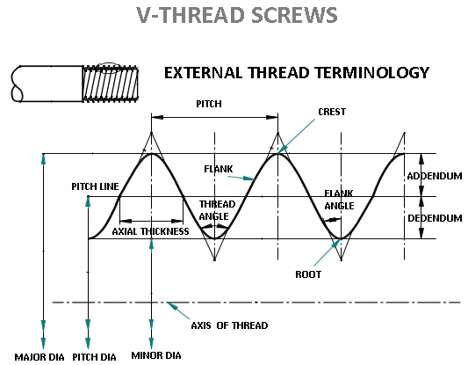

This types of screw threads are also known as Unified Thread. It has a 60° thread angle. The profile os this thread with standard proportions is shown in Fig. The dimensions of the internal thread are is slightly different from that of the external thread.

### ****Square Thread****

Since these **types of screw threads** are in the form of a square, it is called **Square thread**. The flanks or the sides of this thread are perpendicular to the axis of the thread. The depth and thickness of the thread are equal to half the pitch.

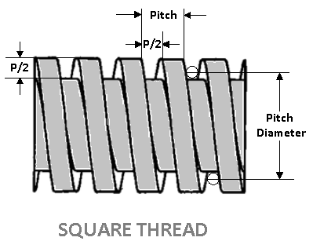

Since the root and crests of the square threads are 90° sharp corners which are likely to work quickly when pit it uses. hence the crests and roots are modified in the actual threads.

The square thread is quite square in section. It is used for transmission of motion and power as in vices, clamps etc. And for converting a rapid rotary motion into slow linear motion, as for example, the lead screw of a lathe, screw presses, jacks, etc,

There are less friction and fewer wear threads of this form, but they are more expensive to cut on a lathe.

### ****Acme Thread****

This thread is the modified form of a square thread. Unlike the square thread, it is easier to cut and stronger at the root.

The angle of the thread is 29°. The inclined sides of the thread facilitate quick and easy engagement and disengagement, as for example, the split out of the lead screw of a lathe.

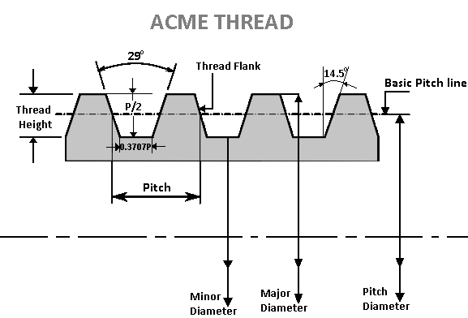

It is suitably used for power screws like the breaks screw, jack screws and on the value operating screw for axial power transmission. The section of this thread with standard proportions is shown in Fig.

The acme thread is a modification of the square thread but it is easier to cut and stronger than square thread.

They are extensively used for transmission of motion and power. The shape of this thread facilitates the used of engaging the split nut as in the lead-screw of a screw-cutting lathe.

### ****Single and Multi-Threads****

In a piece of work, it is possible to have several separate and independent threads running along with it. Accordingly, there are a single threaded screw and multiple or multi-start threaded screw.

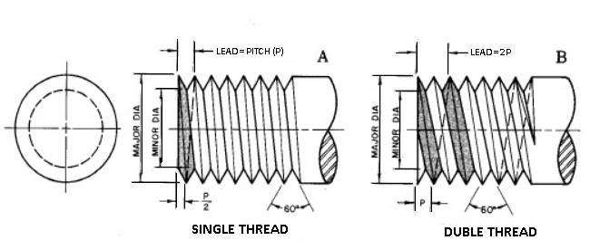

The independent threads are called starts, and we may have single-start, two-start, three-start, etc.

For one complete turn round the screw or bolt then there is a movement of one thread the screw is called a **single-threaded screw**. And when there is a movement of more than one thread, the screw is called multiple or **multi-start threaded screws**.

In the case of a three-start thread, for one complete turn, the thread advances three times as far if it were a single thread. Multi-start threads are used in cases where rapid movement or motion is needed, where they are widely employed.

### Right-hand and Left-hand Threads

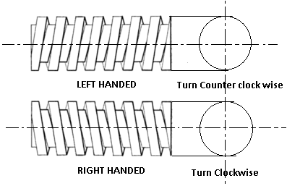

Screw threads may be made either right or left-handed. A right-hand thread is one in which the nut must be turned in a right-handed direction to screw it on, a left-hand thread being one on which the nut would be screwed on by turning it to the left. Figure illustrate these examples.

# 

## Chapter 4

# Screw Thread

## ****Screw Thread Terminology****

**Following are the terms used screw thread terminology:**

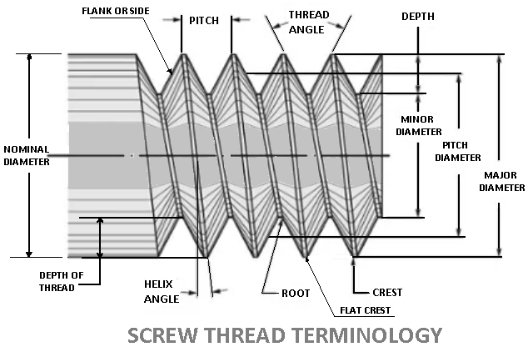

The Following definitions refer to the various term used in screw threads. The various **elements of a screw thread**are shown in fig. The external thread is the thread cut on the outer surface of a rod. The internal thread cut on the inner surface of a hole.

1. Root
2. Crest
3. Flank or side
4. The angle of the thread
5. The depth of thread
6. Nominal diameter
7. Major diameter
8. Minor, core, or root diameter
9. Pitch diameter
10. Pitch
11. Lead

### Description of Terms

#### ****1. Root****

It is the bottom portion of the surface of a thread, either flat or rounded which joins the sides of the adjacent threads.

#### ****2. Crest****

It is the top portion of the surface of a thread,either flat or rounded which joins the sides of the same threads.

#### ****3. Flank or Side****

It is the surface of a thread that connects the crest with the root and also it offers the surface contact with its counterpart.

#### ****4. The Angle of The Thread****

It is the angle included between the sides of the two adjacent threads and measured on an axial plane.

#### ****5. The Depth of The Thread****

**I**t is the distance between the crest and the root of a thread which is measured normal to the axis on an axial plane. It is designated as h3.

#### ****6. Nominal Diameter****

It is the diameter of the cylindrical rod on which the threads are cut. This diameter specifies the size of the screw.

#### ****7. Major Diameter****

It is the diameter of an imaginary coaxial cylinder which bounds the crest of an external thread or the roots of an internal thread.

D and d denote the major diameters of the internal and external threads respectively.

#### ****8. Minor, or Core, or Root Diameter****

**I**t is the diameter of an imaginary coaxial cylinder which bounds the roots of an external thread or the crests of an internal thread.

* D1 and d3 denote the minor diameters of the internal and external threads respectively.

#### ****9. Pitch Diameter****

It is the diameter of the thread at which an imaginary coaxial cylinder that can be passed so as to cut the thread so that the width will be equal to the width of the groove.

* D2 and d2 denote the pitch diameters of internal and external threads respectively.

#### ****10. Pitch****

It is the distance from a point on a screw thread to the corresponding point on the next thread, measured parallel to the axis. It may be indicated as the distance from crest to crest, or from root to root, but the former is the convention.

#### ****11. Lead****

It is the axial distance advanced by a nut for its one full turn over a threaded rod. On a single start thread, the lead and the pitch are identical.

The cross-sectional shape of a thread is often called its *form* or *thread form* (also spelled *thread form*). It may be [square](https://en.wikipedia.org/wiki/Square_(geometry)), [triangular](https://en.wikipedia.org/wiki/Triangle), [trapezoidal](https://en.wikipedia.org/wiki/Trapezoid), or other shapes. The terms *form* and *thread form* sometimes refer to all design aspects taken together (cross-sectional shape, pitch, and diameters), but commonly refer to the standardized geometry used by the screw. Major categories of threads include machine threads, material threads, and power threads.

Most triangular thread forms are based on an [isosceles triangle](https://en.wikipedia.org/wiki/Isosceles_triangle). These are usually called *V-threads* or *vee-threads* because of the shape of the [letter V](https://en.wikipedia.org/wiki/V). For 60° V-threads, the isosceles triangle is, more specifically, [equilateral](https://en.wikipedia.org/wiki/Equilateral_triangle). For [buttress threads](https://en.wikipedia.org/wiki/Buttress_thread), the triangle is [scalene](https://en.wiktionary.org/wiki/scalene).

The theoretical triangle is usually [truncated](https://en.wiktionary.org/wiki/truncation) to varying degrees (that is, the tip of the triangle is cut short). A V-thread in which there is no truncation (or a minuscule amount considered negligible) is called a *sharp V-thread*. Truncation occurs (and is codified in standards) for practical reasons—the thread-cutting or thread-forming tool cannot practically have a perfectly sharp point, and truncation is desirable anyway, because otherwise:

* The cutting or forming tool's edge will break too easily;
* The part or fastener's thread crests will have [burrs](https://en.wikipedia.org/wiki/Burr_(metal)) upon cutting, and will be too susceptible to additional future burring resulting from dents (nicks);
* The roots and crests of mating male and female threads need clearance to ensure that the sloped sides of the V meet properly despite error in pitch diameter and dirt and nick-induced burrs.
* The point of the thread form adds little strength to the thread.

In [ball screws](https://en.wikipedia.org/wiki/Ball_screw), the male-female pairs have bearing balls in between. [Roller screws](https://en.wikipedia.org/wiki/Roller_screw) use conventional thread forms and threaded rollers instead of balls.

### Angle

The included angle characteristic of the cross-sectional shape is often called the *thread angle*. For most V-threads, this is standardized as 60 [degrees](https://en.wikipedia.org/wiki/Degree_(angle)), but any angle can be used. The cross section to measure this angle lies on a plane which includes the axis of the cylinder or cone on which the thread is produced.

# Chapter 5

**Two wire method**

Effective Diameter Measurements The effective diameter or the pitch diameter can be measured by. Any one of the following methods: (i) The micrometer method (ii) The one wire, two wires, or three wire or rod methods. Theory: Effective diameter of screw thread is the diameter of pitch cylinder which is coaxial with the axis of the screw and intersects the flanges of the thread in such way as to make width of thread and the width of spaces between the threads equal. This is the most important dimension as it decides the quality of the fit between screw thread micrometer and two and three wire method. In Two Wire Method, The effective diameter of a screw thread may be ascertained by placing two wires or rods of identical diameter between the flanks of the thread, as shown in Fig. and measuring the distance over the outside of these wires. The effective diameter E I s then calculated as E=T+P, Where T= Dimension under the wires = M-2d, M=dimension over the wires, d= diameter of each wire The wires used are made of hardened steel to sustain the wear and tear in use. These are given a high degree of accuracy and finish by lapping to suit different pitches. Dimension T can also be determined by placing wires over a standard cylinder of diameter greater than the diameter under the wires and noting the reading R1 and then taking reading with over the gauge, say R2. Then T= dm-(R1-R2). P=It is a value which depends upon the diameter of wire and pitch of the thread. If P= pitch of the thread, then P= 0.866p-d (for metric thread) and Effective Diameter E= T+P.

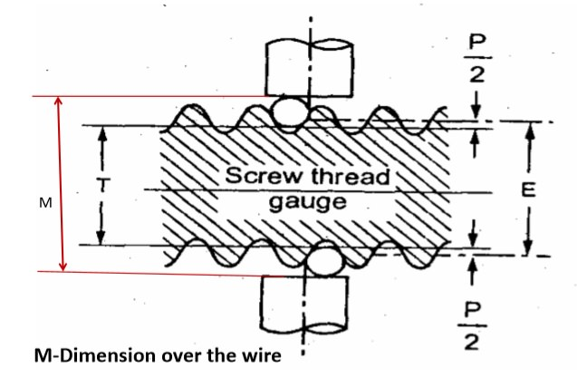

1. **ANGLE OF THREAD**- This is the angle included between the sides of the thread measured in an axial plane. **It is represented by the letter A**. The half angle is represented by a small letter a. The angle of thread is known from the name of the thread. All Unified form and National threads have a 60° angle. Acme and some Worm threads have a 29° angle, and Whitworth threads have a 55° angle.

2. **PITCH**-This is the distance from a point on the screw thread to a corresponding point on the next thread measured parallel to the axis of the thread. It is represented by the letter p. (p=1/n).

a. **FED-STD-H28** uses the Greek letter alpha “?” for ½ included angle of Thread (Axial Plain). In Appendix A, we use the English “a”.

3. **DEPTH OF THREAD**- This is the distance from the crest to the root of the thread measured perpendicular to the axis of the screw or nut. ** It is represented by the letter **h**.

4. **MAJOR DIAMETER**- This is the largest diameter of the screw or nut. ** It is represented by the letter **D**. No formula is needed for the major diameter as it is used to identify the size of the screw. For instance a ¼” – 20 screw is one having a major diameter of 1/4 inch, and 20 thread per inch.

5. **PITCH DIAMETER**-The basic thread pitch diameter is the diameter where the thread thickness is equal to the space between the threads. If the flats at the top and bottom of the thread are the same, the **pitch diameter**will coincide with the middle of the sloping side of the thread. ** The pitch diameter is represented by the letter **E**.

**Formula E = D – Depth of thread = D – h  
Or E = D – Twice addendum**

6. **MINOR DIAMETER**- This is the smallest diameter of the screw or nut. On the nut it corresponds to the tap drill size. ** It is represented by the letter K.

**Formula K = D – 2 X Depth of Thread = D -2h**

7. **LEAD ANGLE**- This is the angle made by the pitch helix, with a plane perpendicular to the axis. ** It is represented by the letter s or .

Formula tan

**NOTE:**The reader is invited to refer to FED-STD-H28 and ANSI B1.7 for additional definitions having to do with elemental and dimensional information concerning screw threads.

8. **BEST SIZE WIRES**. * Wires which touch the thread at the pitch diameter are known as “Best Size” Wires. Such wires are used because the measurements of pitch diameter are least affected by errors that may be present in the angle of the thread. The diameter of the measuring wires is represented by the letter **G**.

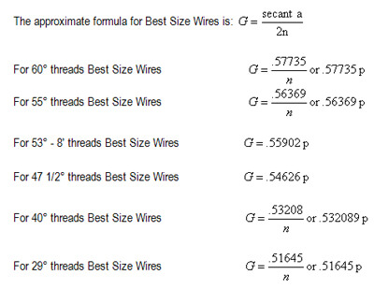

Chapter 6

## Approximate Formulas for Measured Pitch Diameter

## Approximate Formulas for Measured Pitch Diameter

The following approximate formulas for computing the **pitch diameter**, from the measurement over wires, should be used only for screws having lead angles from 0° to 5°. These formulas neglect the effect of lead angle and give results which show the screw to be larger than the true condition. The formulas are for any [wire size which will fit in the thread](https://www.threadcheck.com/3-wire-thread-measuring/).

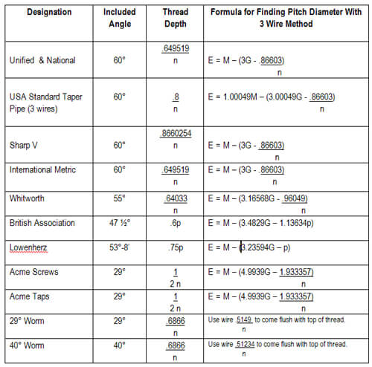

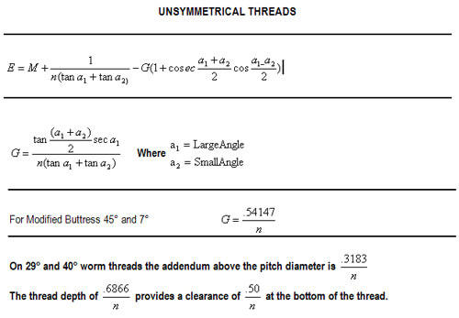

## Approximate Formulas for Basic Measurement Over Wires

When cutting or grinding a screw thread, it is desirable to know what the measurement over wires would be for a screw of the theoretical basic size. The following approximate formulas are the same as those on the preceding page, but transposed and referred to the basic outside diameter of the screw. The same qualifications apply as were listed on the preceding page.

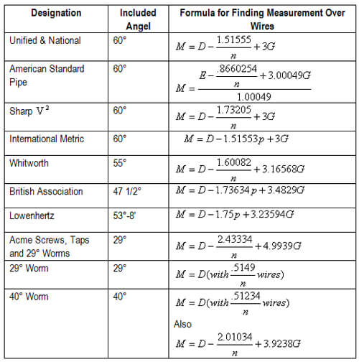

**Chapter 7**

**Advantages**

* A very important property of a screw thread is that it can be used to amplify force: A small torque applied to a screw can exert a large axial force on a mass. Therefore, a threaded component is said to produce a Mechanical Advantage.
* Self-Locking Effect
* One of the big benefits of thread forming screws is the self-locking effect. Because they form their own threads, there are no gaps between male and female threads. This can lead to rotational loosening under vibration loads. This self-locking feature alone can be a good reason to switch.
* Reduction of Fasteners
* By eliminating nuts or costly tapping operations, as well as locking washers, adhesives or other locking elements, realizing cost savings over the entire joint is possible. Not to mention reducing the number of fasteners and operations needed for conventional assembly.
* Specialty Thread Formers for Light Alloy Metals and Plastics
* Many specialty type thread forms exist for assembly into light alloys such as magnesium or aluminum. They also exist for various thermoplastic materials. For some harder thermoplastics or thermoset plastics, adding a cutting feature can lessen the stress on the material. This will still create threads into the material eliminating tapping or costly threaded inserts.

**Chapter 8**

**Disadvantages**

* Shared state –

Global variables are shared between threads: Inadvertent modification of shared variables can be disastrous

* Many library functions are not thread safe.
* Lack of robustness: If one thread crashes, the whole application crashes
* Parts joined by **threaded** joints are vulnerable to failure due to stress concentration near the holes.
* Due to time and labor taken in manual assembly the cost in tightening a **screw** can be up to six times the cost of **screw** itself.

**Chapter 9**

**Application**

**1. According to location**

External screw thread (on bolts etc.)

Internal screw thread (in nuts etc.)

**2. According to configuration**

Straight (helical) – most common, e.g., bolts, studs etc.

Taper (helical), e.g., in drill chuck

radial (scroll) as in self-centering chuck

**3 . According to the direction of the helix**

right hand (common)

left hand (occasionally)

**4.According to form**

vee thread (600 or 550 angle) – most common

acme thread (290)

square thread (generally in power screws)

buttress thread (45o)

worm thread (290 ~ 400)

semicircular (groove section) thread being used in recirculating type bolts, screws.

**5.According to standard**

BSW (British Standard Whitworth); thread – size is designated by TPI (threads per inch)

metric thread; thread size is specified by pitch or lead (in mm)

fastening : screws, nut-bolts and studs having screw threads are used for temporarily fixing one part on to another part

• joining : e.g., co-axial joining of rods, tubes etc. by external and internal screw threads at their ends or separate adapters

• clamping : strongly holding an object by a threaded rod, e.g., in c-clamps, vices, tailstock on lathe bed etc.

• controlled linear movement : e.g., travel of slides (tailstock barrel, compound slide, cross slide etc.) and work tables in milling machine, shaping machine, cnc machine tools and so on.

• transmission of motion and power : e.g., lead screws of machine tools

• converting rotary motion to translation : rotation of the screw causing linear travel of the nut, which have wide use in machine tool kinematic systems

• position control in instruments : e.g., screws enabling precision movement of the work table in microscopes etc.

• precision measurement of length : e.g., the threaded spindle of micrometers and so on.

• acting as worm for obtaining slow rotation of gear or worm wheel

• exerting heavy force : e.g., mechanical presses

• conveying and squeezing materials : e.g., in screw conveyor, injection molding machine, screw pump etc.

**Chapter 10**

**Conclusions**

* : Using the Floating Carriage Micrometer diameter of imaginary cylinder i.e.
* Effective or pitch diameter can be evaluated. Thus, both the linear and angular measurements have their own importance in industries.

# Gear reduction via worm drives

# Moving objects linearly by converting rotary motion to linear motion, as in the lead screw of a jack.

# Measuring by correlating linear motion to rotary motion (and simultaneously amplifying it), as in a micrometer.

# Reference

Reference books:

* “Engineering Metrology” by Dr. S. B. Ingole.
* “Engineering Metrology” by R. K. Jain.
* “Linear measurements” by Kenneth S. Curtis.

Reference website:

* www.wikipedia.com
* www.slideshare.com